

# **Discrete Automation Systems**

**Assignment 02**

**Group member:**

Farid Khosravi 267964

Mehdi Mahmoodpour 267958

Palash Halder 267962

**ASE – 9416 Autumn 2016**

**Contents**

1. Contents . . . . . . . . . . . . . . . . . . . . . . . . . . . . . . . . . . . . . . . . . . . . . . . . . . . . . 2
2. Objective: Design basic PLC program . . . . . . . . . . . . . . . . . . . . . . . . . . . . . . 3
3. PLC Flow - chart . . . . . . . . . . . . . . . . . . . . . . . . . . . . . . . . . . . . . . . . . . . . . . . 4
4. PLC State-chart . . . . . . . . . . . . . . . . . . . . . . . . . . . . . . . . . . . . . . . . . . . . . . . 5
5. Difficulties . . . . . . . . . . . . . . . . . . . . . . . . . . . . . . . . . . . . . . . . . . . . . . . . . . . . 6
6. Role Group members . . . . . . . . . . . . . . . . . . . . . . . . . . . . . . . . . . . . . . . . . . . 6

**Objective: Design basic PLC program**

**System:**

The system consists of the following:

* Conveyor-the conveyor is used to deliver the pallets to the workstations.
* Work Station- The workstation works on one pallet at a time for 5 seconds and releases the pallet to the conveyor.
* Pallet- the pallet is inserted to the system to be worked upon and the output product is taken out.

**Design:**

The design is based on the following:

Inputs:

* Start-Stop button for switching ON/OFF the Motor running the conveyor.
* Locked by WS L1, L2, and L3 - WS signals that it already has the pallet for the processing.
* Presence sensors P1, P2, and P3 - sensors telling that there is a pallet in the corresponding location in front of a WS.
* Input Pallet - A button to introduce a pallet to the system at WS1 position.

Outputs:

* Motor - the motor to control the conveyor. It is generally ON, as the pallets are stopped by the stoppers at the WS.
* Stoppers S1, S2, and S3 - to stop a pallet at the corresponding workstation.
* Board available BA1, BA2 and BA3 - to signal to the corresponding workstation that the pallet has arrived.

**Logic & Flow diagram:**

The flow diagram is as shown in fig.1, the logic is based on the following:

* The three buttons namely, Locker, Presence sensor and Input Pallet are responsible for the following:
* Locker-Locks the Pallet at the workstation and prevents other pallets from entering the workstation while it is busy.
* Presence sensor –Signals that the pallet is in position to be received by the workstation.
* Input Pallet –inputs the pallet through WS1.
* The pallet is introduced to the system at WS1, then each pallet must visit WS2 and WS3. The logic is explained below:
* With respect to BA’x’ and L’x’ signals the logic can look as follows: A pallet arrives at WS’x’, the program checks L’x’.

1. If L’x’ is true the pallet continues by the conveyor to the next WS.
2. If L’x’ is false and the pallet needs the service of that WS, then BA’x’ signal goes on. The BA’x’ signal should go off once Lx goes on, which means that the WS’x’ has taken the pallet.
3. The pallet is then in the WS’x’ (for 5 seconds).
4. Then, after the processing, the pallet is returned to the conveyor belt and L’x’ goes off.
5. The pallet can be returned from the WS to the conveyor belt, if and as there is no any other pallet - Px and BAx inputs are off.)

* The pallet that have visited all the workstations is removed from the system at the WS1.
* Each workstation can process 1 pallet at a time. It takes 5 seconds for a workstation to process the pallet.
* When the workstation is busy processing a pallet and a new pallet comes to its location, the pallet bypasses the workstation and continues on the conveyor to check other workstation. The pallet will again check the availability of the workstation in the next loop. It is does not matter in which order the WS’s are visited. The pallet is available to output only after all the WS’s has worked on it.

**The PLC-flow chart:**

**shows the steps of the process**

1. START is ON- Motor ON.
2. Checks the counter value. i.e. the number pallets in the system. If 10 pallets are present it disables the input button.
3. Checks state of WS1, if it is working enters, the system via WS2, if WS2 is busy enters the system via WS3.
4. Checks the workstation tags of the pallet. Inputs the pallet at WS1. If WS1 is busy the pallet goes to WS2. If WS2 is busy it goes to WS3.
5. The pallet continues in the conveyor until it gets all the workstation tags.
6. After receiving all the workstation tags the pallet is made available to be taken out of the system.

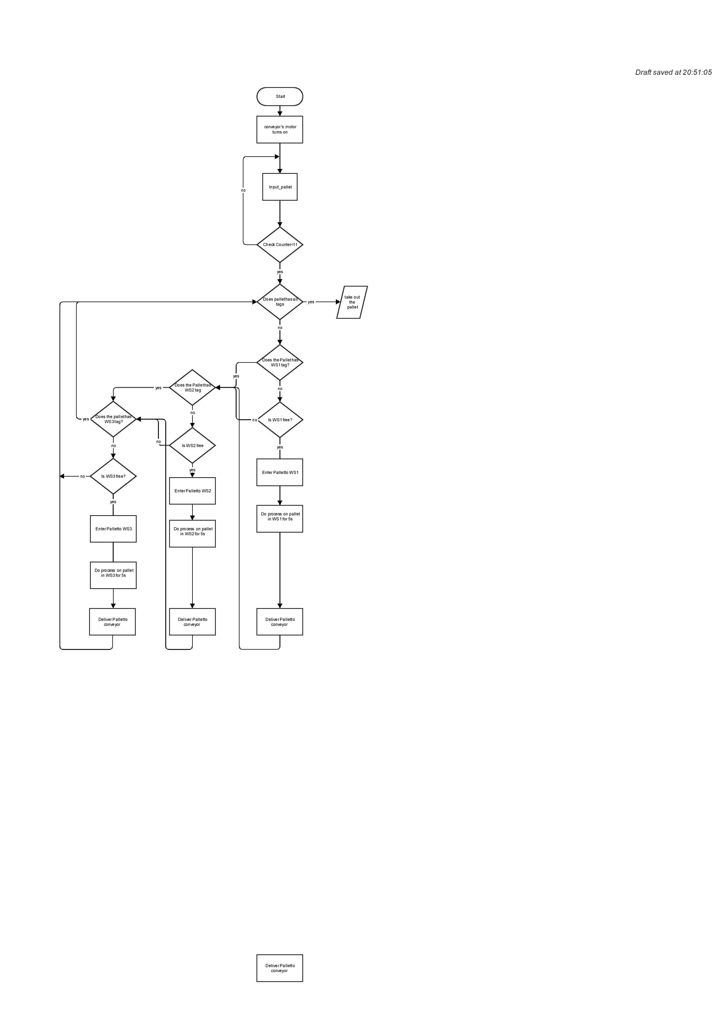

Fig.1 Flowchart

**The PLC-state chart:**

**shows the steps of the process**

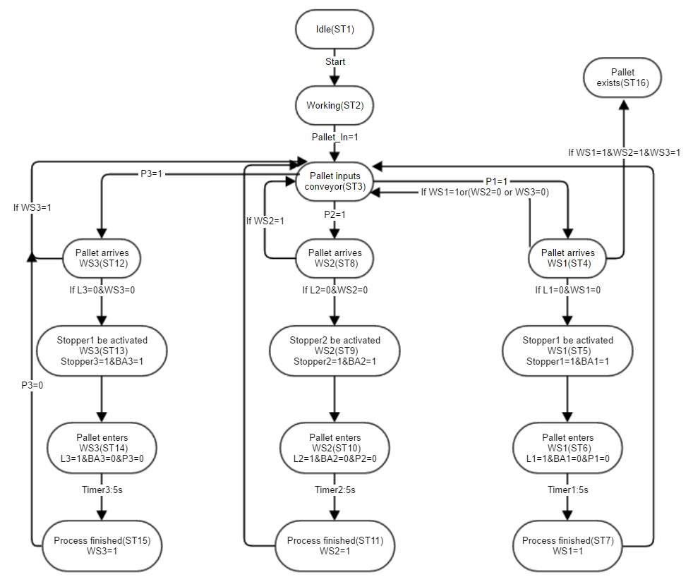

**Difficulties :**

* Assigning memory to each pallet.
* Ability of the system to work independently of any sequence.
* Defining array to each pallet and defining the workstation tags as the array element of respective pallet.
* Resetting timer outside the conditions.
* Difficulty in inserting single pallet using “for loop”.
* Even if we try to insert pallet with individual input pallet button, the difficulty of resetting the “TON timer” for the other incoming pallets persists.

**Role of each group member:**

* **Farid Khosravi:** FinalStructured Text programming and visualization.
* **Mehdi Mahmoodpour:** Visualization, video recording and report writing.
* **Palash Halder:** 2nd structured text programing andVisualization and writing report.